**Kubernetes Task**

**Task Description:**

Setup minikube at your local and explore creating namespaces (Go through official documentation).

Step 1: Minikube version

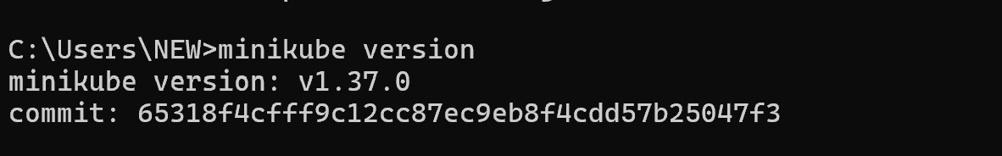

Step 2: Start Minikube with Docker

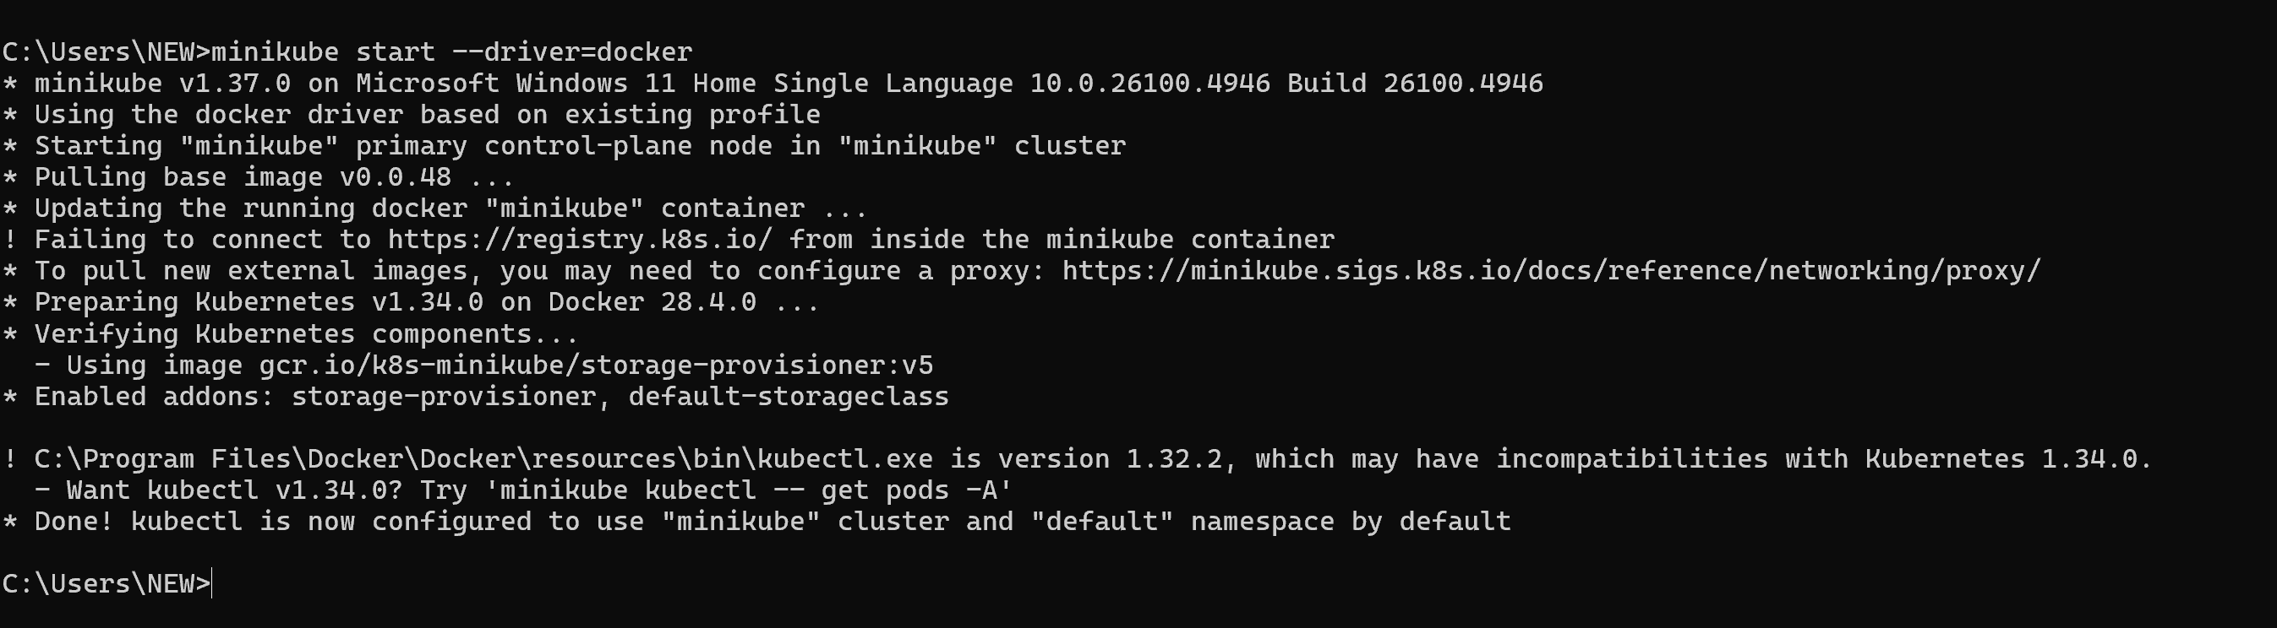

Step 3: Minikube status

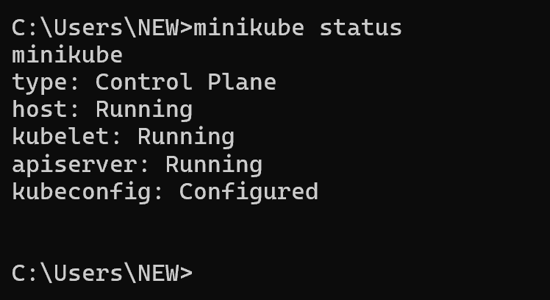

Step 4: Verify installed minikube

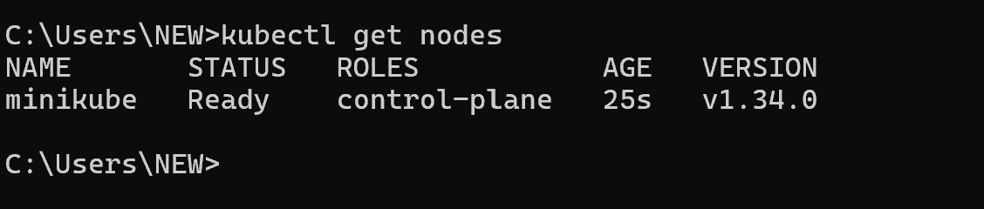

Step 5: View Existing Namespaces

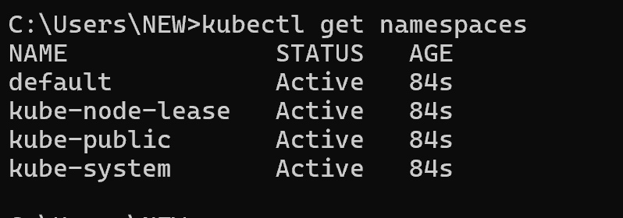

Step 6: Create new namespaces

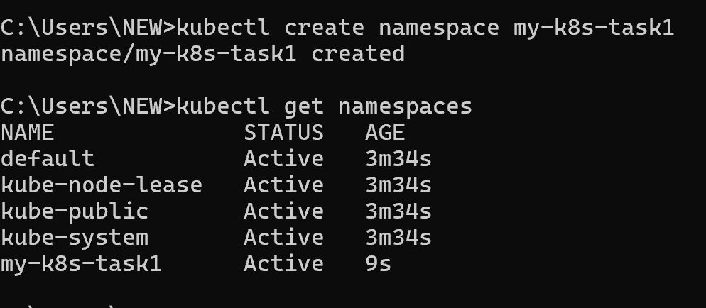

Step 7: Deploy the app in a namespace

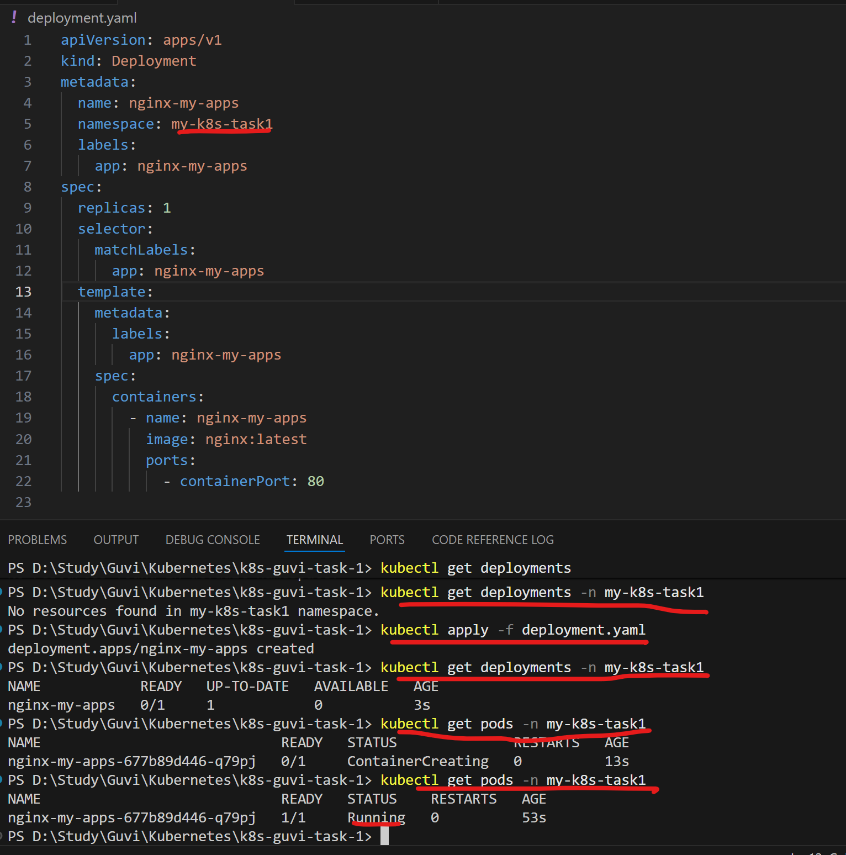

Step 8: Expose the App

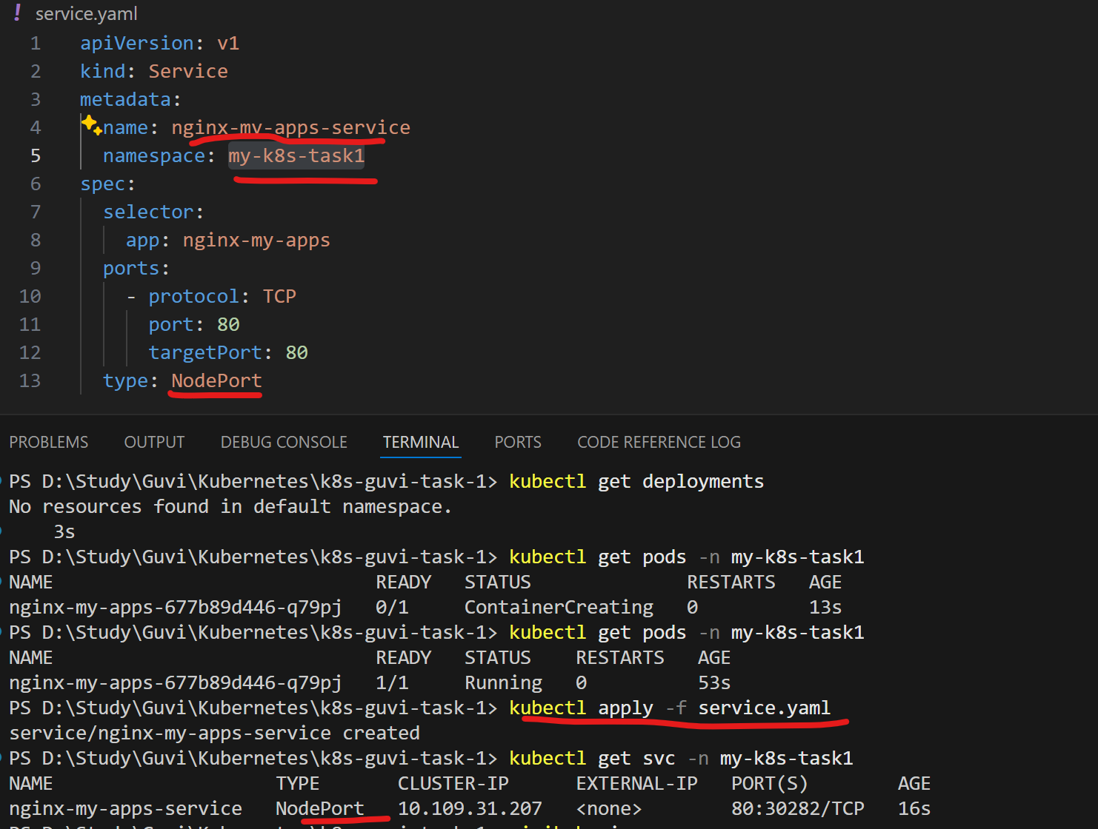

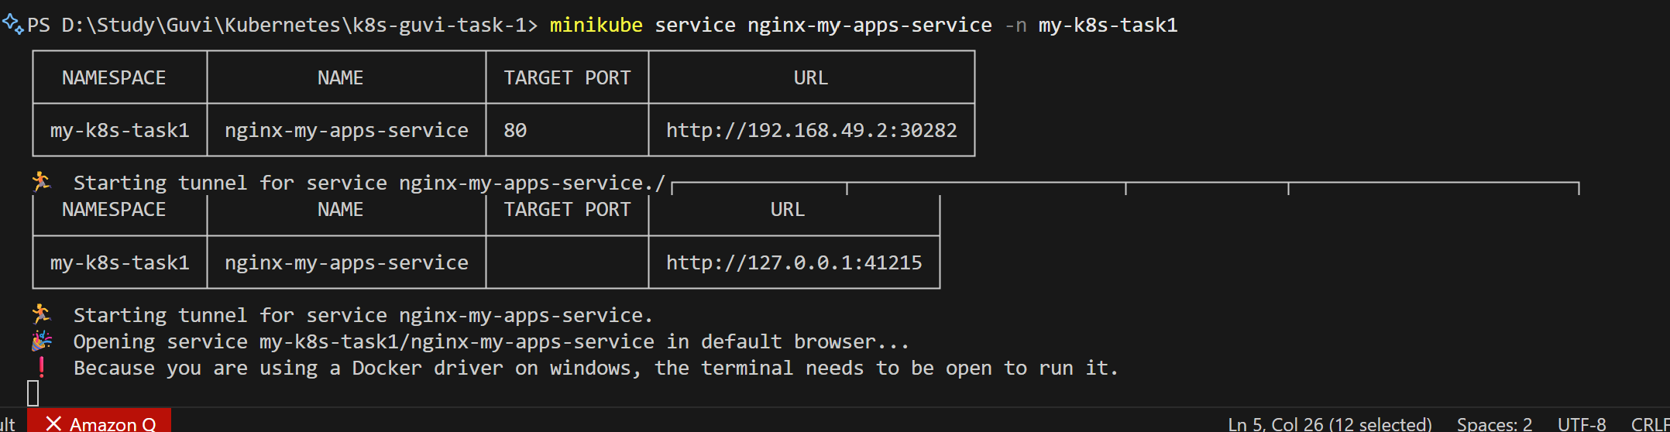

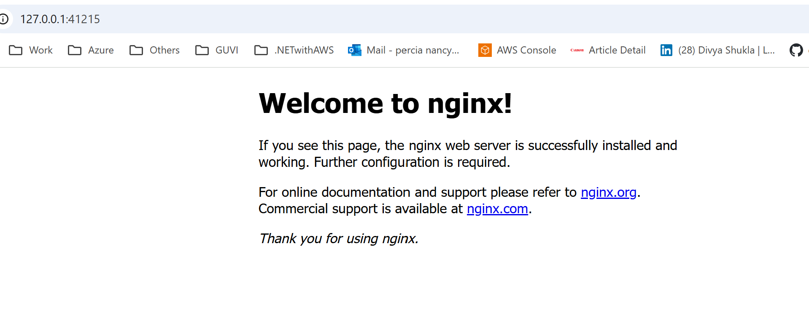

Step 9: Delete the namespace

